**What make a good project.**

Lot of data, good data analysis

Meets all expectations of the rubric

Very well laid out, be clear on steps of DMAIC

Time plots (run chart)

Hypothesis test, copy appropriate colored chart into presentation

Use a control chart

Thought process map

Data chart

Measures of central tendency

Show the work for calculations!!!! (SQL number)

Pareto chart??

Good use of tools and conclusion from tools

Conclusion slide!

NEED TO CALCULATE MINIMUM REQUIRED SAMPLE SIZE

It’s okay if you have too much or too little data.

**What makes a bad project.**

Do not include raw data

Not clear definition of the problem

No work shown of how values calculated

No description of how data collected

Use minimum 5 tools!

No axis labels on charts

No mention of SQL

No data measurement plan or data stratification tree

Not labeling typing of chart (ex , say it’s a Pareto chart, run chart, etc)

No conclusion based on analysis

Go look at comments for 3.12 and 4.7 in coursework.

Data_sets_excel_async_examples in files

Improvement_tools_list_wDMAIC.doc in files

**Chapter 9 Quiz Review**

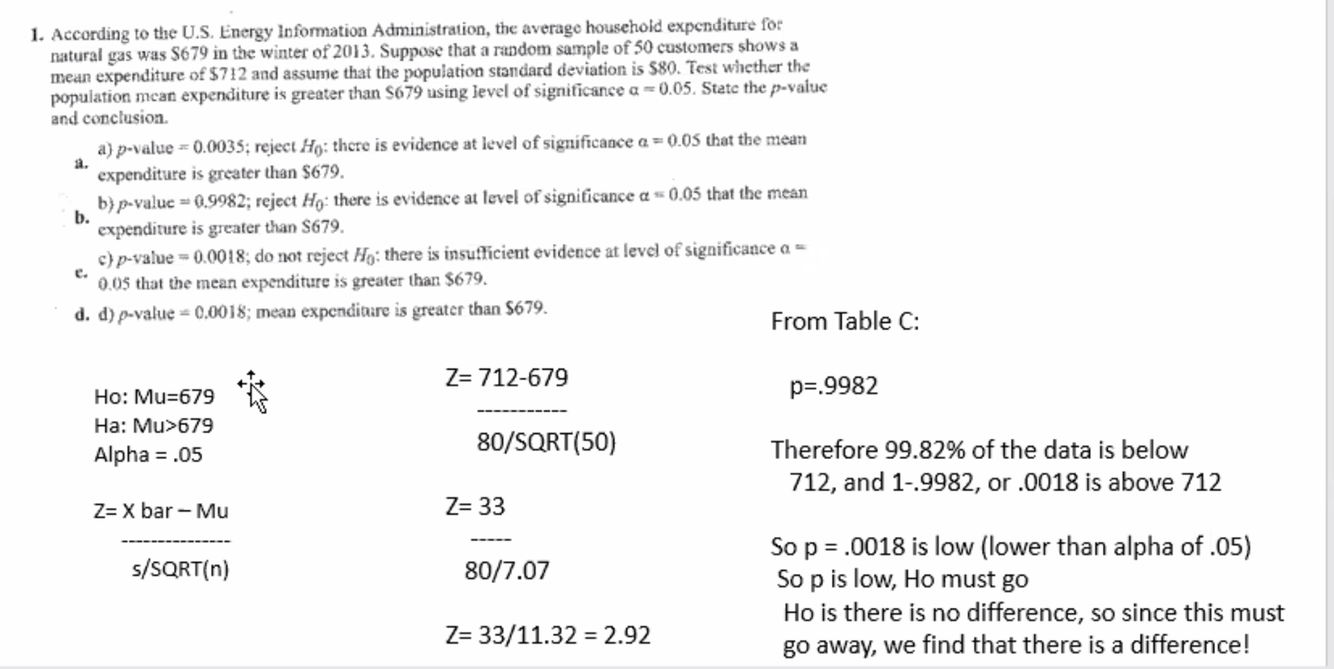

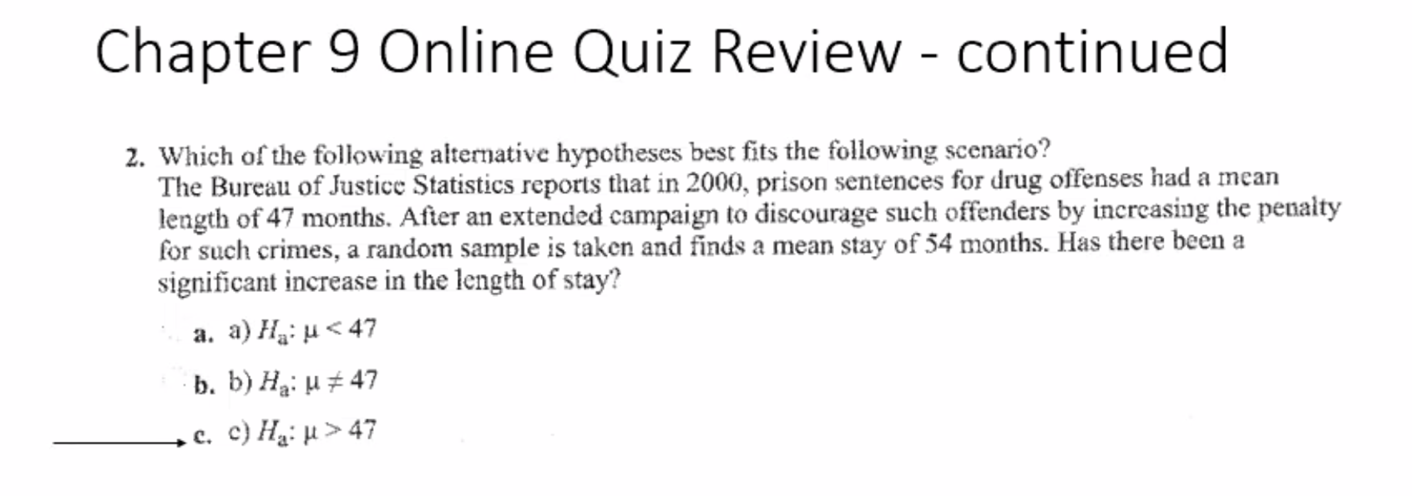

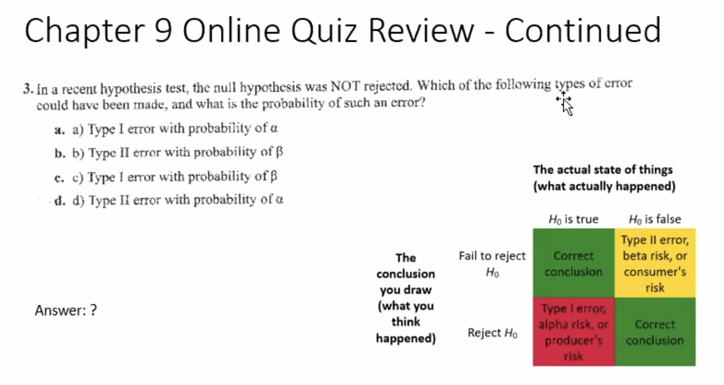

B. Type I error with probability of beta

